Write a program in assembly language to print single character on screen.

ORG 100h ; Origin, to specify that the program starts at 100h (COM file format)  
  
; Read a single character from user  
MOV AH, 01h ; Function 01h of INT 21h is used to read a character from input  
INT 21h ; Call DOS interrupt to get the character  
MOV DL, AL ; Store the input character from AL register to DL for printing  
  
; Print the character on screen  
MOV AH, 02h ; Function 02h of INT 21h is used to print a character  
INT 21h ; Call DOS interrupt to print the character  
  
; Terminate the program  
MOV AH, 4Ch ; Function 4Ch of INT 21h terminates the program  
INT 21h ; Call DOS interrupt to exit  
  
END ; End of program

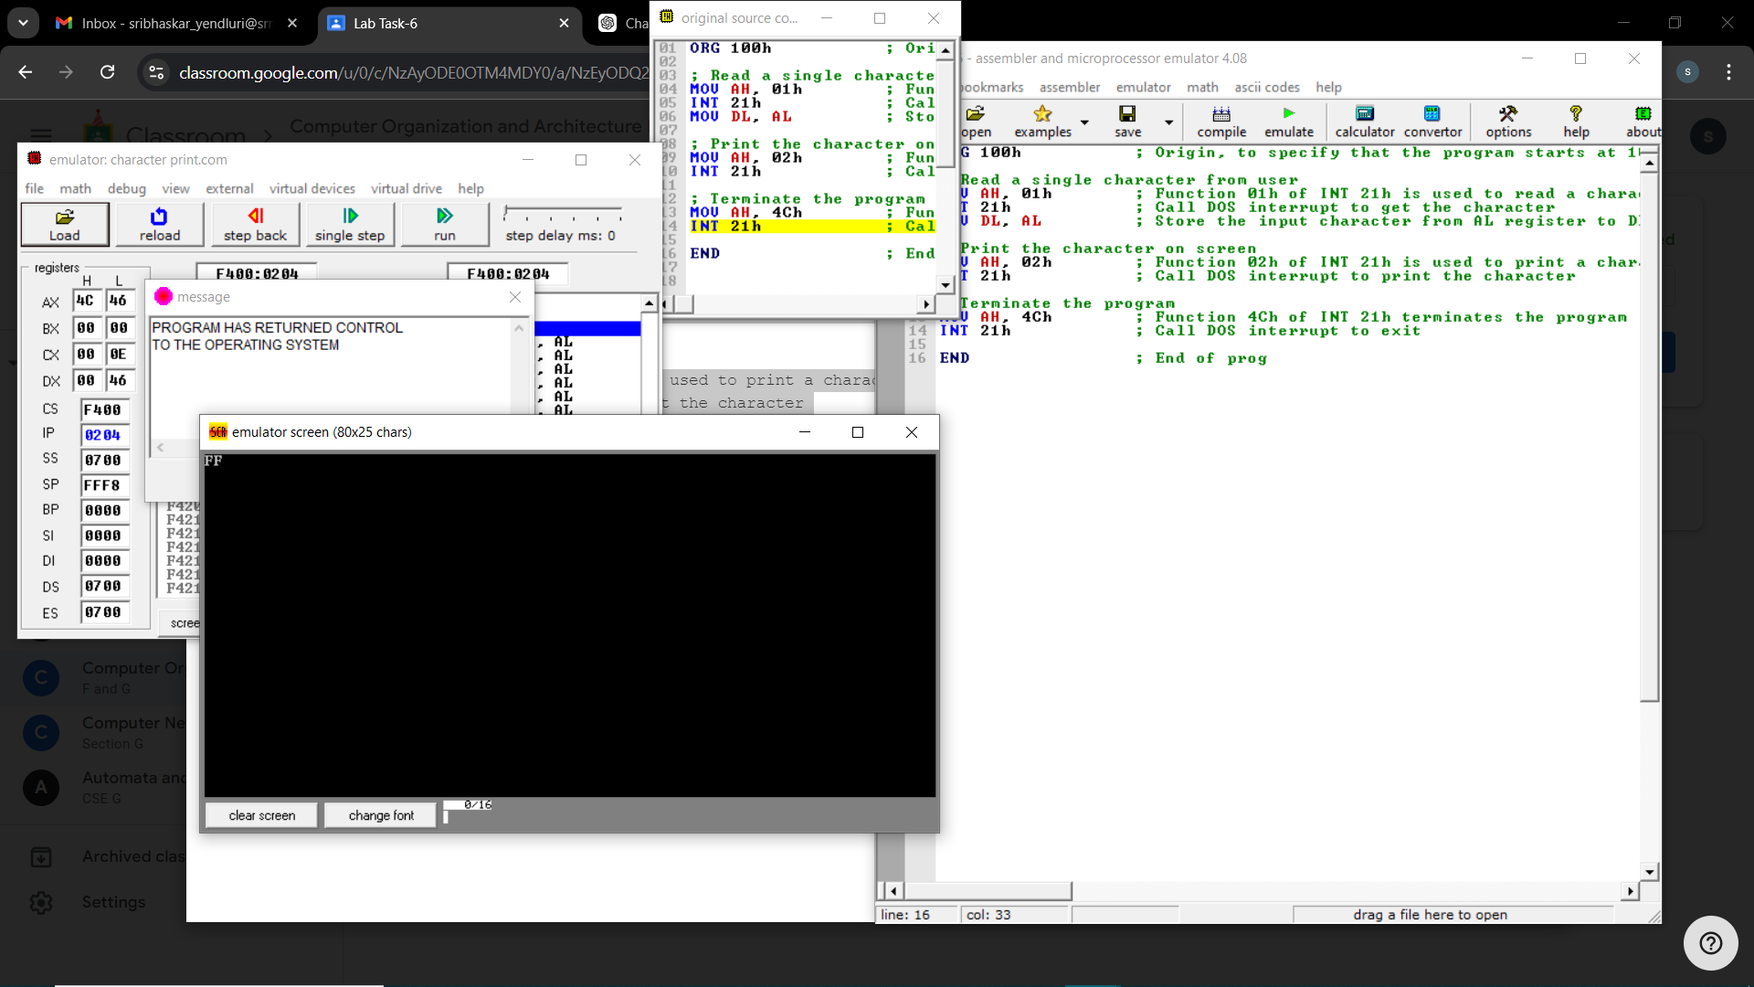

Write an assembly language program to convert an upper-case letter to the

corresponding lower-case letter.

ORG 100h ; Origin, to specify that the program starts at 100h (COM file format)  
  
; Display message "Enter an uppercase letter: "  
MOV DX, OFFSET msg_input ; Load the address of the message  
MOV AH, 09h ; Function 09h of INT 21h is used to display a string  
INT 21h ; Call DOS interrupt to print the message  
  
; Read a single character from the user  
MOV AH, 01h ; Function 01h of INT 21h is used to read a character  
INT 21h ; Call DOS interrupt to get the character  
MOV AL, AL ; Store the input character in AL  
  
; Check if the character is an uppercase letter (A-Z)  
CMP AL, 'A' ; Compare AL with 'A'  
JL NotUpperCase ; If the input is less than 'A', it is not uppercase  
CMP AL, 'Z' ; Compare AL with 'Z'  
JG NotUpperCase ; If the input is greater than 'Z', it is not uppercase  
  
; Convert the uppercase letter to lowercase  
ADD AL, 20h ; Add 32 (20h) to convert uppercase to lowercase  
  
; Print the message "The lowercase letter is: "  
;MOV DX, OFFSET msg_output ; Load the address of the output message  
;MOV AH, 09h ; Function 09h of INT 21h is used to display a string  
;INT 21h ; Call DOS interrupt to print the output message  
  
; Print the converted lowercase letter  
MOV DL, AL ; Move the lowercase letter to DL  
MOV AH, 02h ; Function 02h of INT 21h is used to print a single character  
INT 21h ; Call DOS interrupt to print the character  
JMP EndProgram ; Jump to the end of the program  
  
NotUpperCase:  
; If the input is not an uppercase letter, display an error message  
MOV DX, OFFSET msg_error ; Load the address of the error message  
MOV AH, 09h ; Function 09h of INT 21h is used to display a string  
INT 21h ; Call DOS interrupt to print the error message  
  
EndProgram:  
; Terminate the program  
MOV AH, 4Ch ; Function 4Ch of INT 21h terminates the program  
INT 21h ; Call DOS interrupt to exit  
  
msg_input DB 'Enter an uppercase letter: $'  
msg_output DB 0Dh, 0Ah, 'The lowercase letter is: $' ; Output message  
msg_error DB 0Dh, 0Ah, 'Error: Not an uppercase letter! $' ; Error message  
  
END ; End of program

